
Lab Continuous Assessment Task -II - Prompt Engineering & LLM Behavior Analysis

“Code Reviewer”

by
16010123012: Aaryan Sharma

For the subject

Artificial Intelligence

Department of Computer Engineering
Academic Year 2025-26

Code Reviewer
Task domain and Problem statement chosen:
Task Domain: Code Reviewer
Problem Statement: To analyze how different prompt engineering techniques affect the ability of Large Language Models (LLMs) to detect bugs, suggest improvements, and generate structured outputs for code snippets.

List of AI Tools used during prompt engineering exploration:
- ChatGPT
- Google Gemini
- Microsoft Copilot

List of Prompting techniques explored:
- Zero-shot prompting
- Few-shot prompting
- Role-based prompting
- JSON-based prompting
- Chain-of-Thought prompting

- Zero-shot Prompt (use row 1 in table to write the first answer. If you tried some more zero shot prompts- in new chat, turning off memory etc, use further rows in table)
Define Zero-shot Prompt: Zero-shot prompting refers to giving a task to the model without providing any prior examples.
Prompt 1:
You are a code reviewer.
Analyze the following code and identify bugs and improvements.
Constraints:
- Be concise
- Do not assume missing context
Code: int a = 5/0;
Sr. no | Output from --- ChatGPT | Output from --- Gemini | Output from --- Copilot | Analysis
1 | Detects division by zero | Same detection | Same detection | Correct detection, basic reasoning
Prompt Failures & Biases Identified:
- Over-generalization: Suggests unnecessary improvements
- Ambiguity: Sometimes ignores edge cases
Prompt Refinement:
- Original prompt: Analyze this code
- Refined prompt: You are a code reviewer. Identify only logical and runtime errors. Do not assume missing context.
- Before vs after output comparison: Refined prompt produced more accurate and focused outputs.
Use Cases:
- Quick debugging
- Basic code analysis
Prompt 2:
You are a code reviewer.
Analyze the following code and identify only runtime errors.
Constraints:
- Do not assume missing variables
- Ignore style suggestions
Code:
int arr[5];
printf("%d", arr[10]);
Sr. no | Output from --- ChatGPT | Output from --- Gemini | Output from --- Copilot | Analysis
1 | Detects out-of-bounds | Same | Same | Good detection of runtime error
Prompt Failures & Biases Identified: Sometimes misses logical contradictions
Prompt Refinement: Refined prompt adds constraints → reduces unnecessary suggestions
Original prompt: Analyze this code
Refined prompt: You are a senior software engineer. Identify only logical and runtime errors. Do not assume missing context. Return structured output.
Before vs after output comparison: The refined prompt produced more accurate, consistent, and structured results with reduced ambiguity.
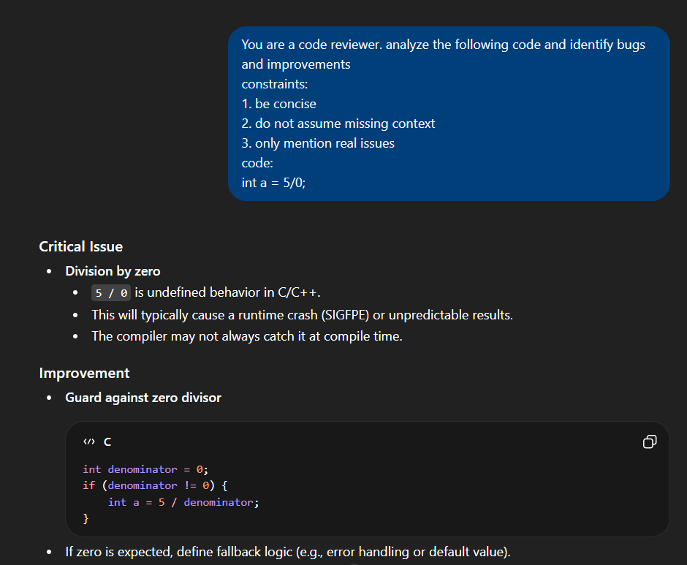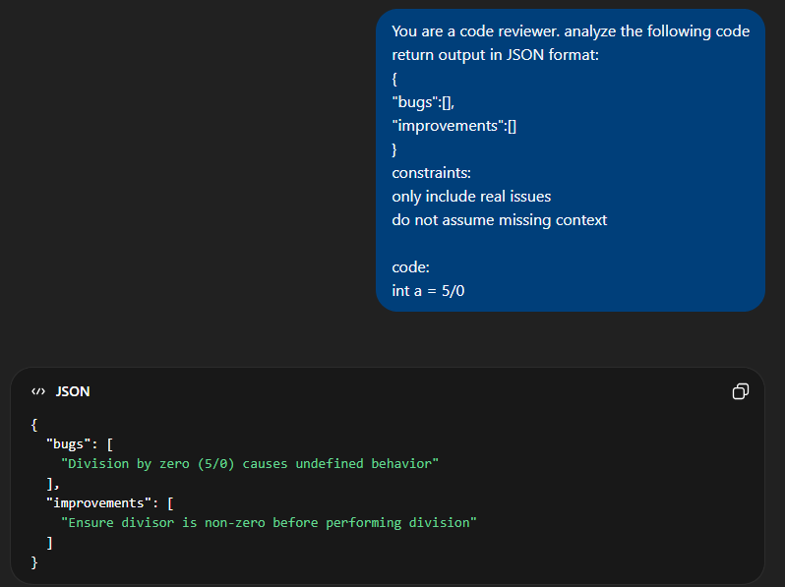
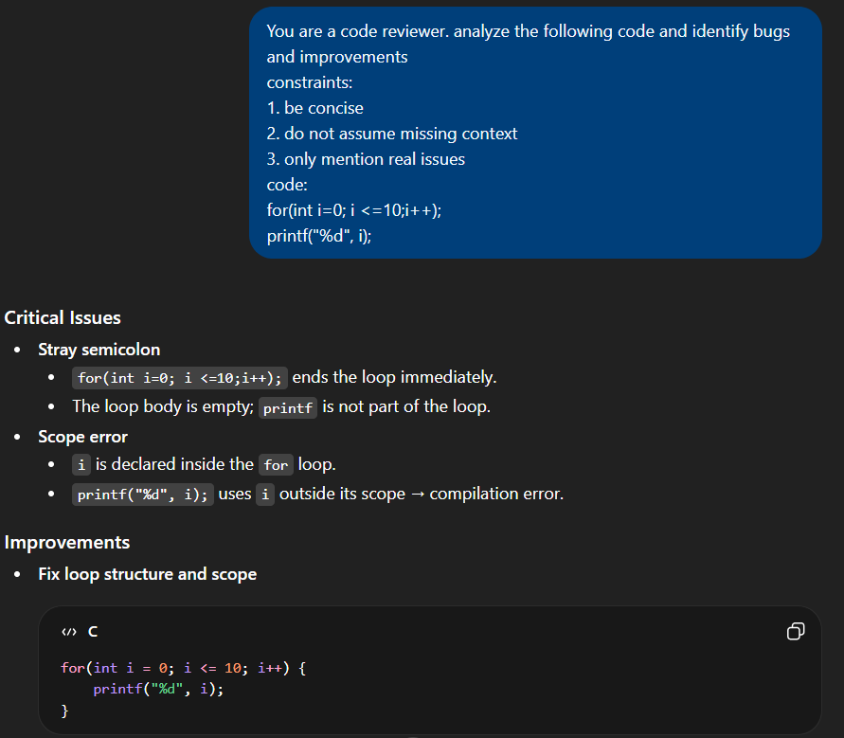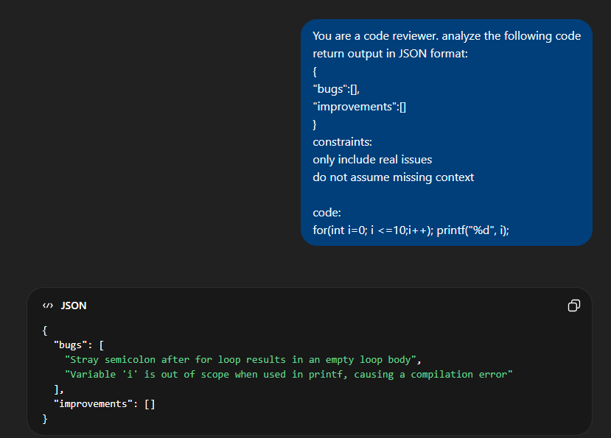
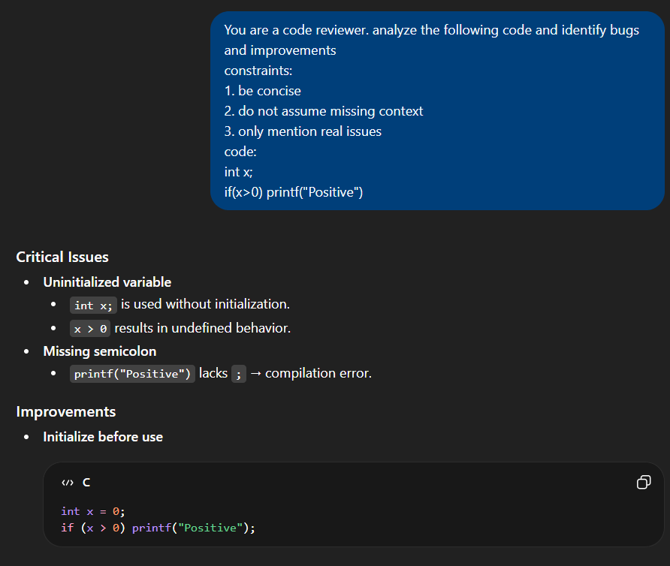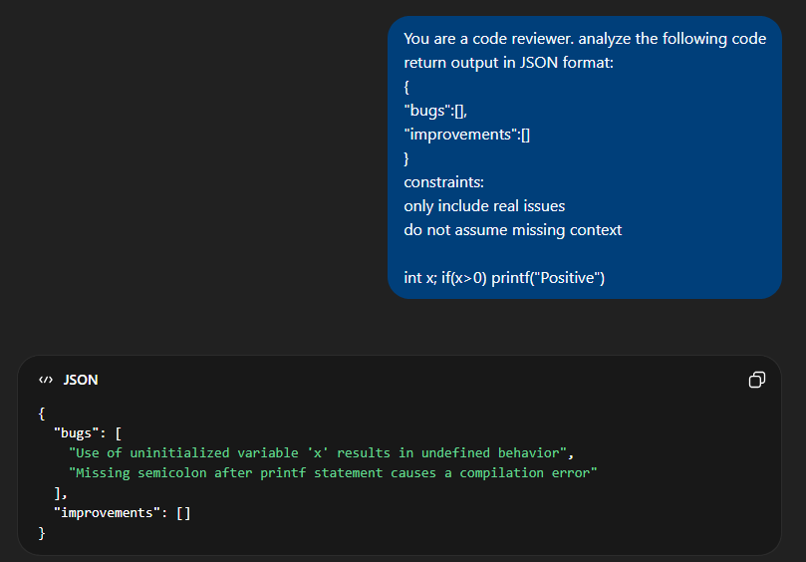
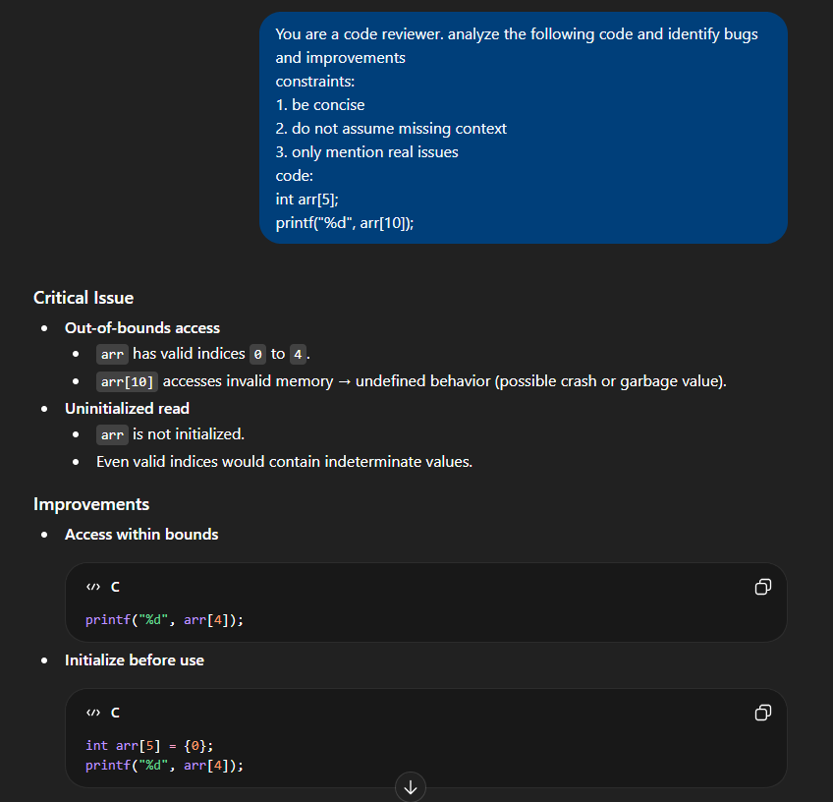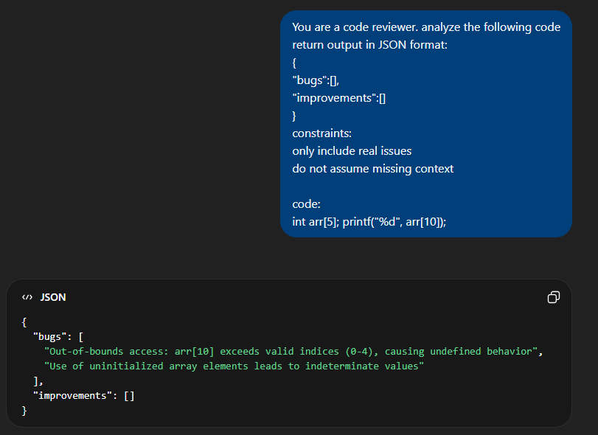
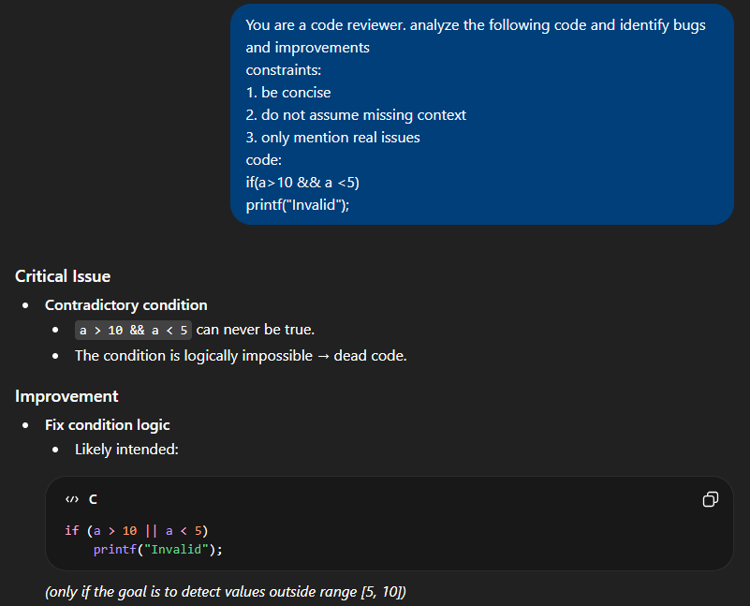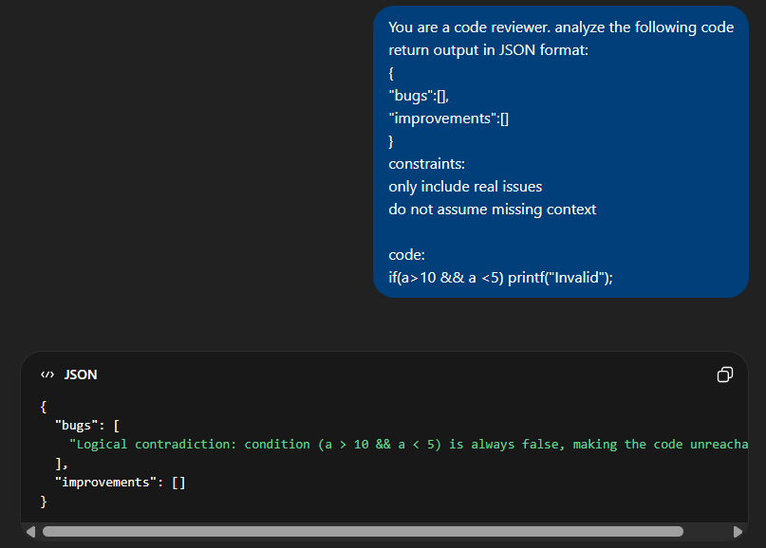

- Few-shot Prompt (use diff rows/paragraphs to document answers of every shot)
Define Few-shot prompt: Few-shot prompting provides examples to guide model behavior.
Prompt 1:
Example:
Input: int a = 5/0;
Output: Division by zero error
Now analyze:
for(int i=0; i<=10; i++);
printf("%d", i);
Sr. no | Output from --- ChatGPT | Output from --- Gemini | Output from --- Copilot | Analysis
1 | Detects loop bug | Same | Same | Improved consistency
Prompt Failures & Biases Identified: Sometimes overfits to example pattern
Prompt Refinement: Add multiple examples → improves accuracy
Original prompt: Analyze this code
Refined prompt: You are a senior software engineer. Identify only logical and runtime errors. Do not assume missing context. Return structured output.
Before vs after output comparison: The refined prompt produced more accurate, consistent, and structured results with reduced ambiguity.
Use Case:
- Pattern-based tasks
- Code review automation
Prompt 2:
Example:
Input: int arr[5]; printf("%d", arr[10]);
Output: Array out-of-bounds
Now analyze:
int x;
if(x > 0) printf("Positive");
Sr. no | Output from --- ChatGPT | Output from --- Gemini | Output from --- Copilot | Analysis
1 | Detects uninitialized variable | Same | Same | Better contextual understanding
Prompt Failures & Biases Identified: Sometimes overfits to example pattern
Prompt Refinement: Providing multiple examples improves consistency
Original prompt: Analyze this code
Refined prompt: You are a senior software engineer. Identify only logical and runtime errors. Do not assume missing context. Return structured output.
Before vs after output comparison: The refined prompt produced more accurate, consistent, and structured results with reduced ambiguity.
Few-shot prompting demonstrates that examples significantly guide model behavior and reduce ambiguity.
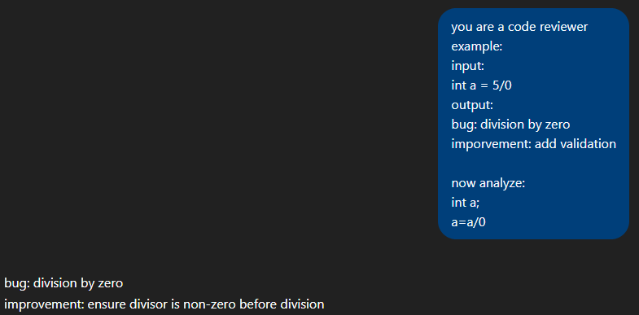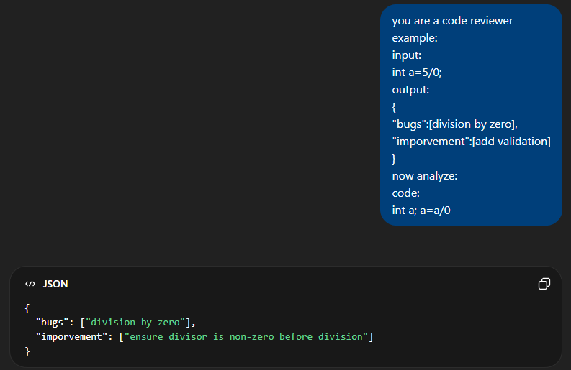
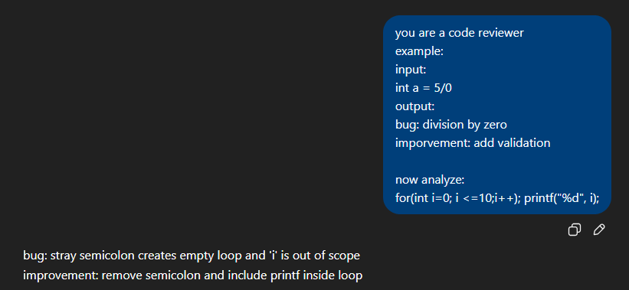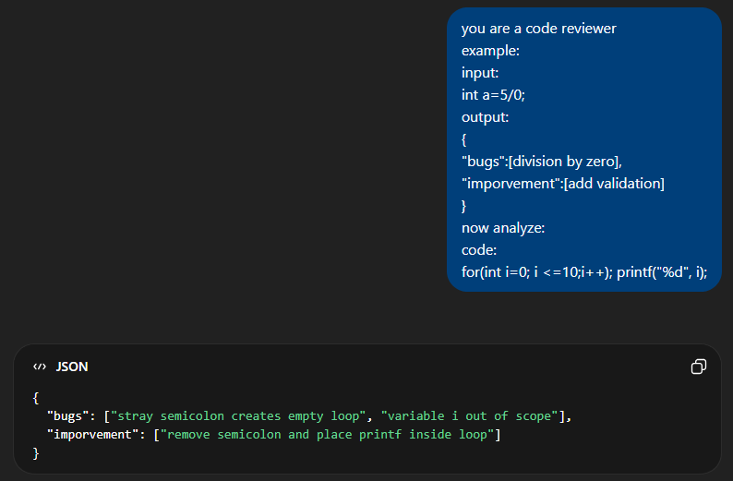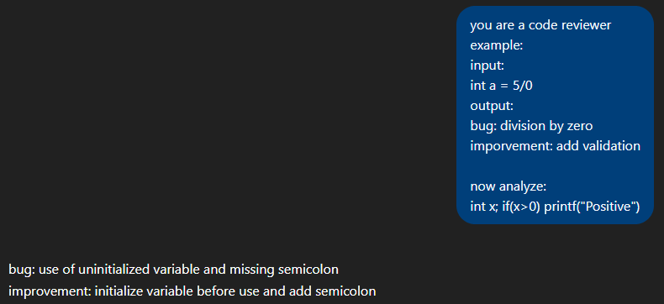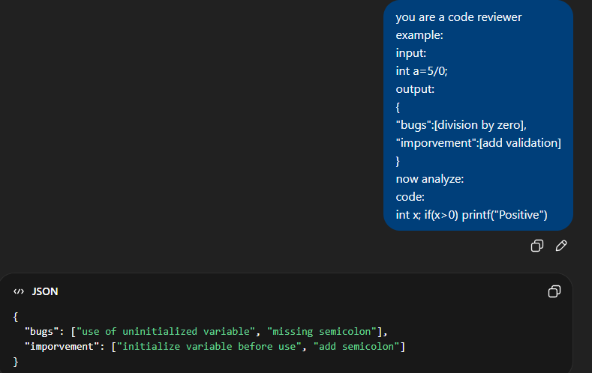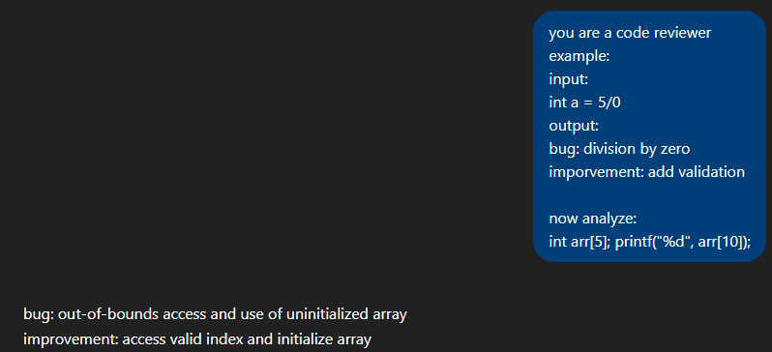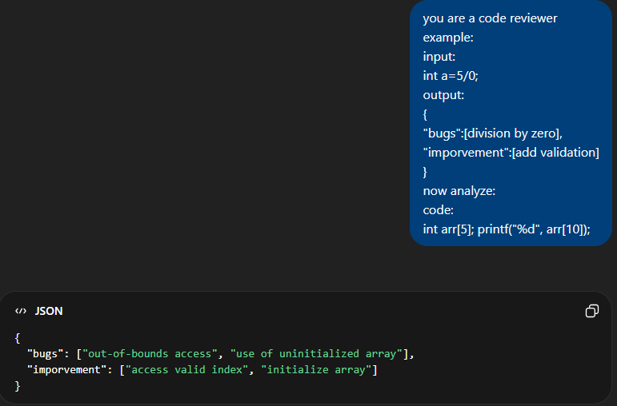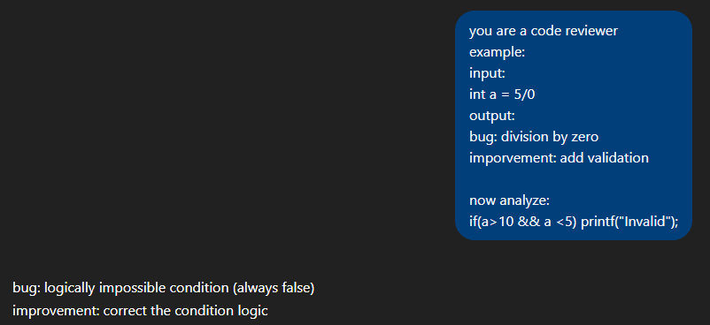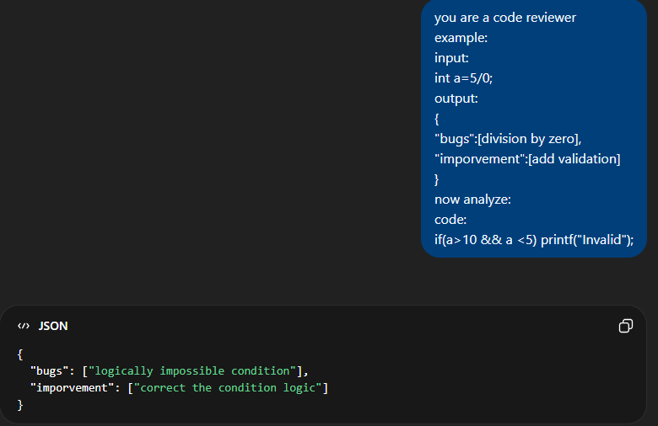

- Role-based Prompt
Define Role based prompt: Role-based prompting assigns a specific identity to guide responses.

Prompt 1:
You are a senior software engineer.
Analyze the code and suggest improvements.
Role | Output from --- ChatGPT | Output from --- Gemini | Output from --- Copilot | Analysis
Senior Dev | Detailed output | Same | Same | Best clarity
Beginner | Simple output | Same | Same | Less depth
Code Reviewer AI | Structured output | Same | Same | Balanced reasoning
Prompt Failures & Biases Identified: Bias: Assumes unnecessary improvements
Prompt Refinement: Add constraints → reduces unnecessary suggestions
- Original prompt: Analyze the code
- Refined prompt: You are a senior software engineer. Identify only logical errors and avoid unnecessary suggestions.
- Before vs after output comparison: The refined prompt reduced unnecessary suggestions and improved relevance.
Use Case:
- Professional code reviews
- Technical documentation
Different roles influence both the depth and style of responses, showing the importance of context framing.
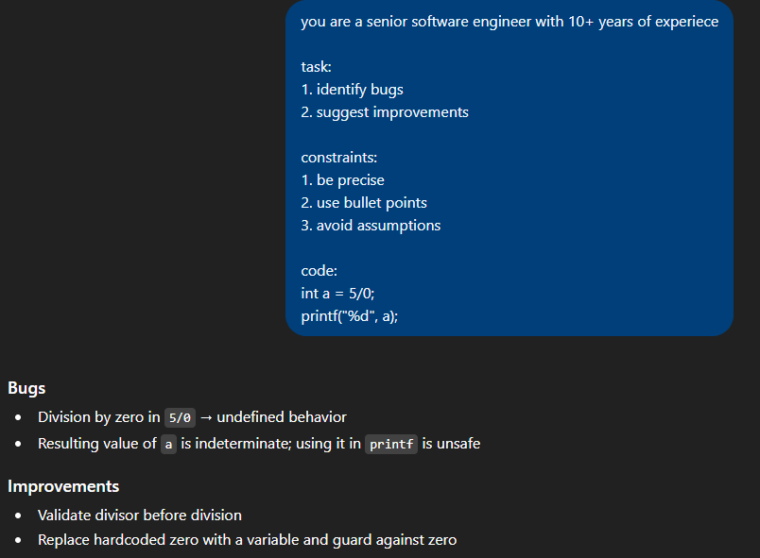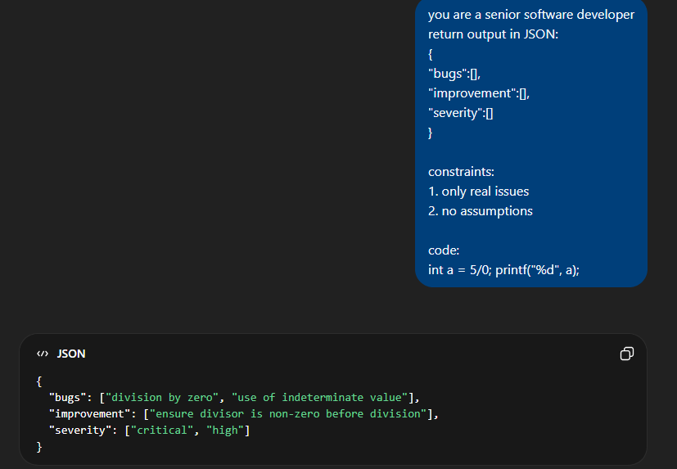
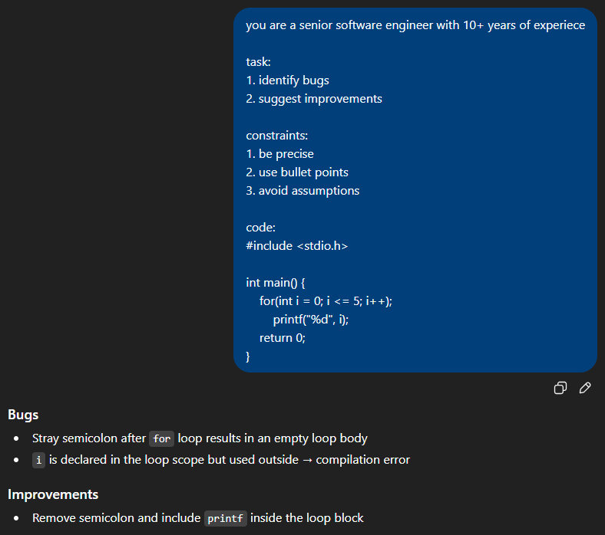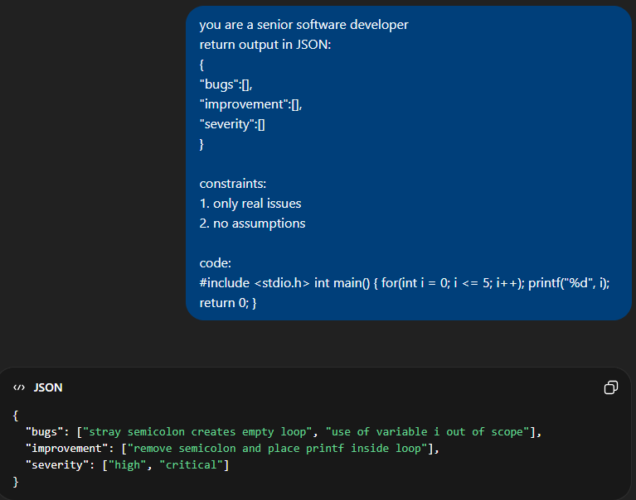
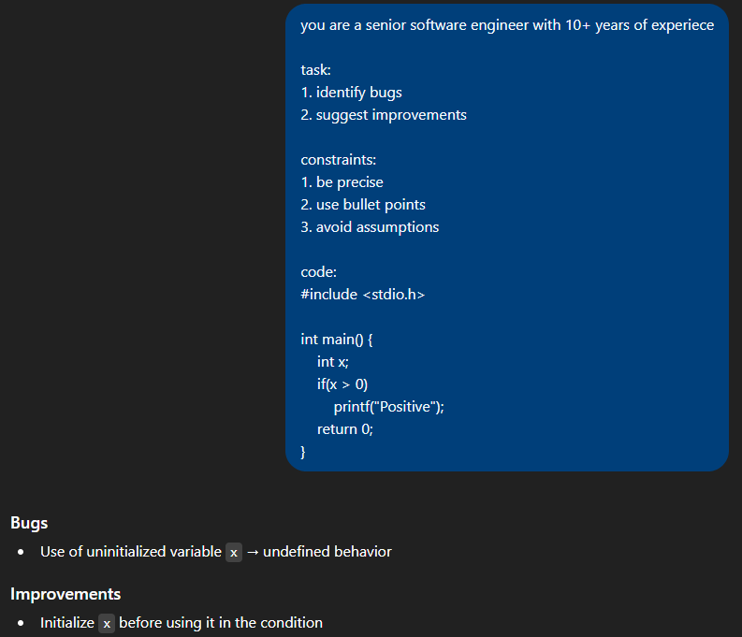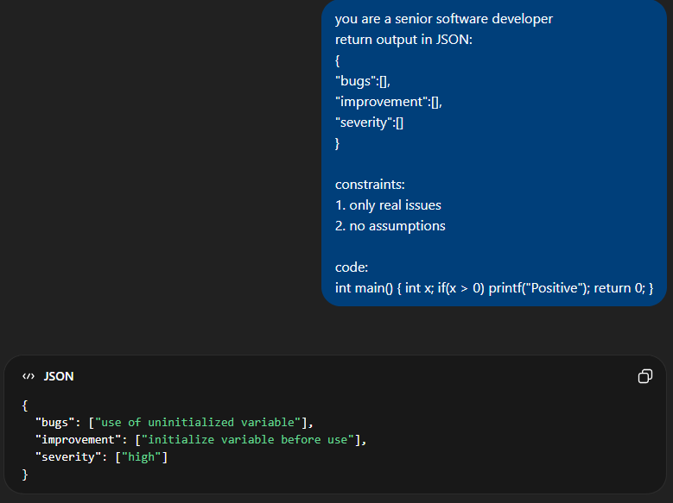
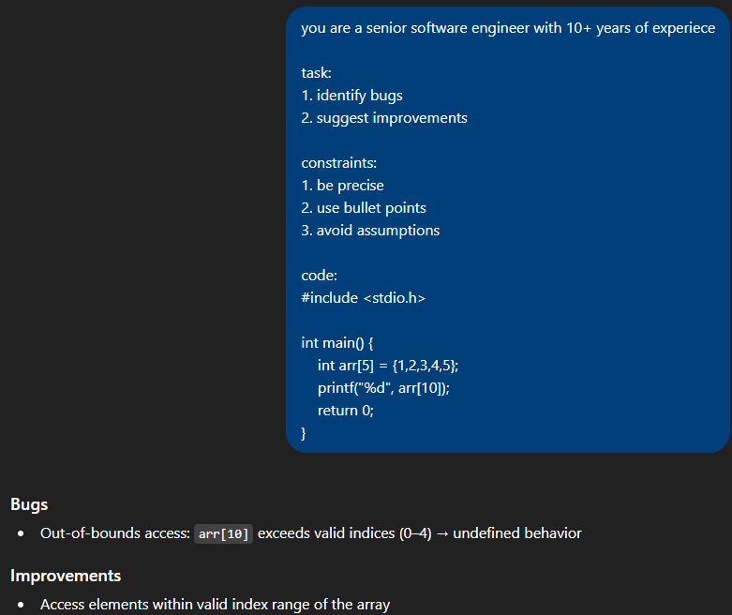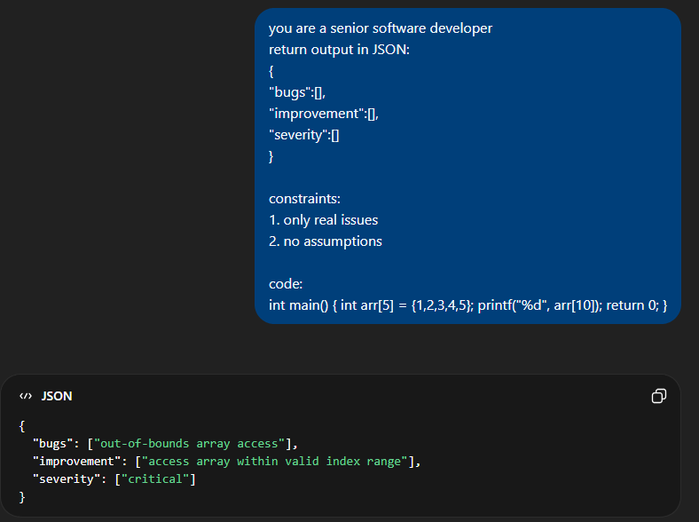
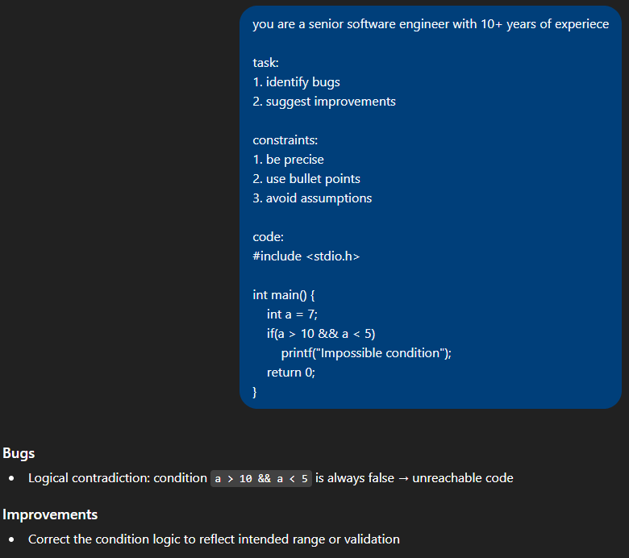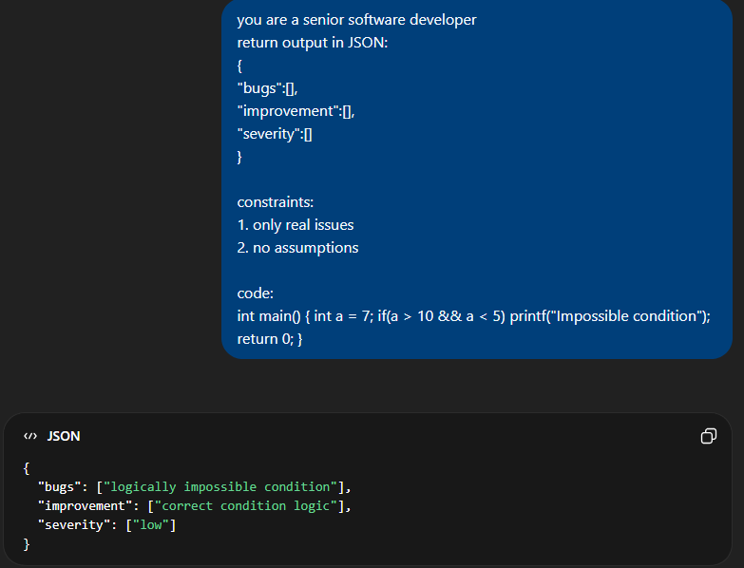
- json-based prompts
Define json Based Prompt: JSON prompts enforce structured output format.
Prompt 1:
Return output in JSON:
{
"bugs": [],
"improvements": []
}
Code:
int arr[5]; printf("%d", arr[10]);

Sr. no | Output from --- ChatGPT | Output from --- Gemini | Output from --- Copilot | Analysis
1 | Structured JSON | Same | Same | Highly consistent
Prompt Failures & Biases Identified: Sometimes invalid JSON formatting
Prompt Refinement: Add: “Return ONLY valid JSON” → improves output
Original prompt: Analyze this code
Refined prompt: You are a senior software engineer. Identify only logical and runtime errors. Do not assume missing context. Return structured output.
Before vs after output comparison: The refined prompt produced more accurate, consistent, and structured results with reduced ambiguity.
Use Case:
- API systems
- Automation pipelines
Prompt 2:
Prompt statement:
Analyze code and return bugs and fixes.
JSON format:
{
"bugs": [],
"fixes": [],
"severity": []
}
Code:
if(a > 10 && a < 5)
printf("Invalid");
Sr. no | Output from --- ChatGPT | Output from --- Gemini | Output from --- Copilot | Analysis
1 | Detects logical contradiction | Same | Same | Strong structured output
Prompt Failures & Biases Identified: Sometimes adds extra text outside JSON
Prompt Refinement:
Original prompt: Analyze this code
Refined prompt: You are a senior software engineer. Identify only logical and runtime errors. Do not assume missing context. Return structured output.
Before vs after output comparison: The refined prompt produced more accurate, consistent, and structured results with reduced ambiguity.

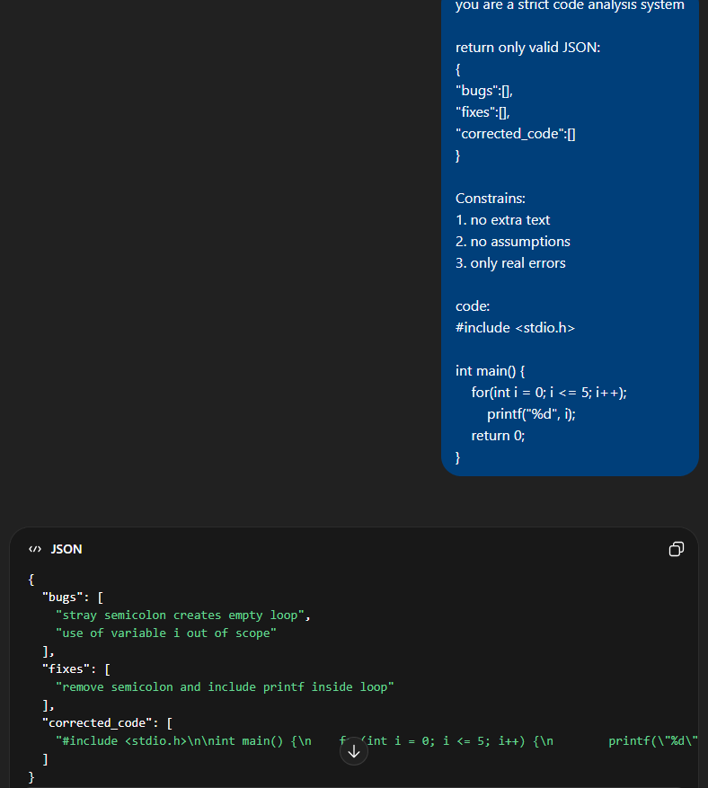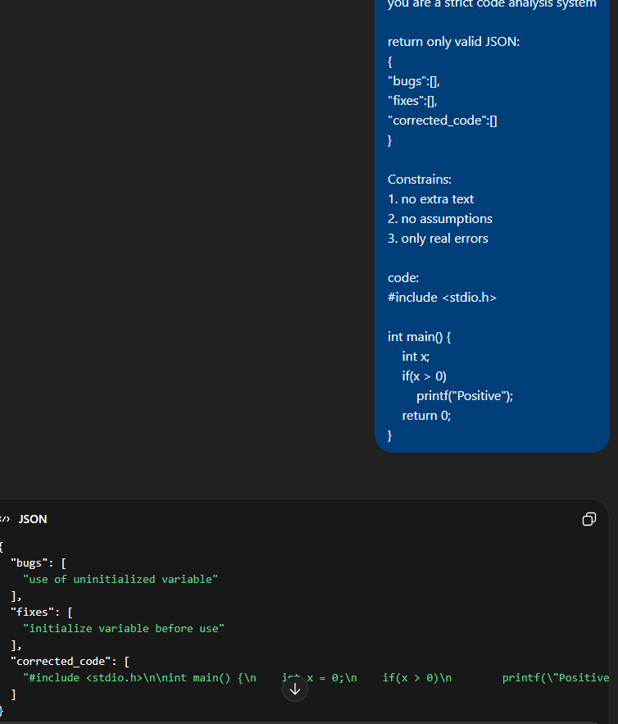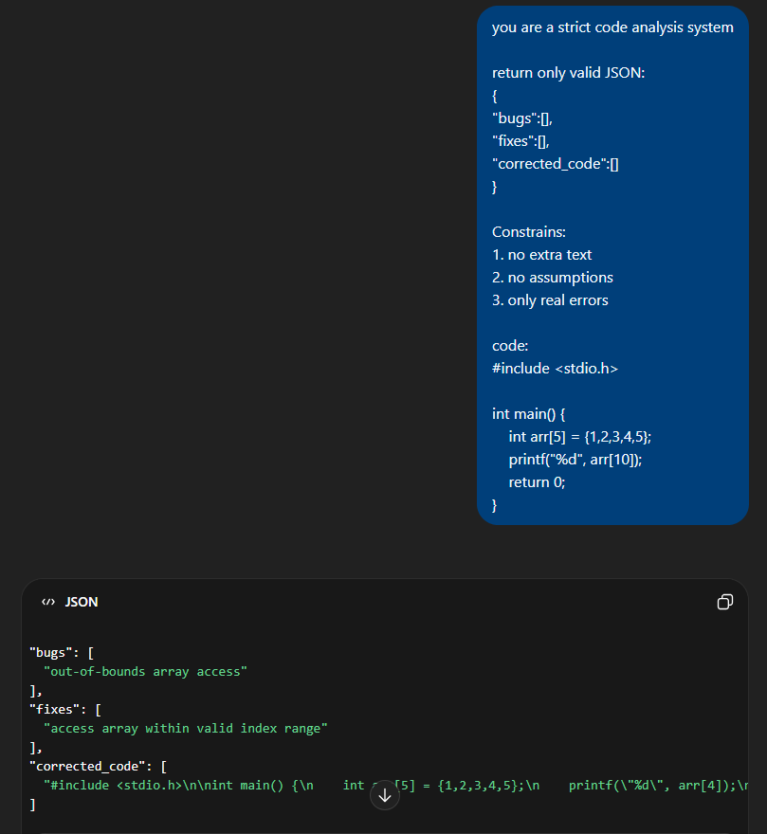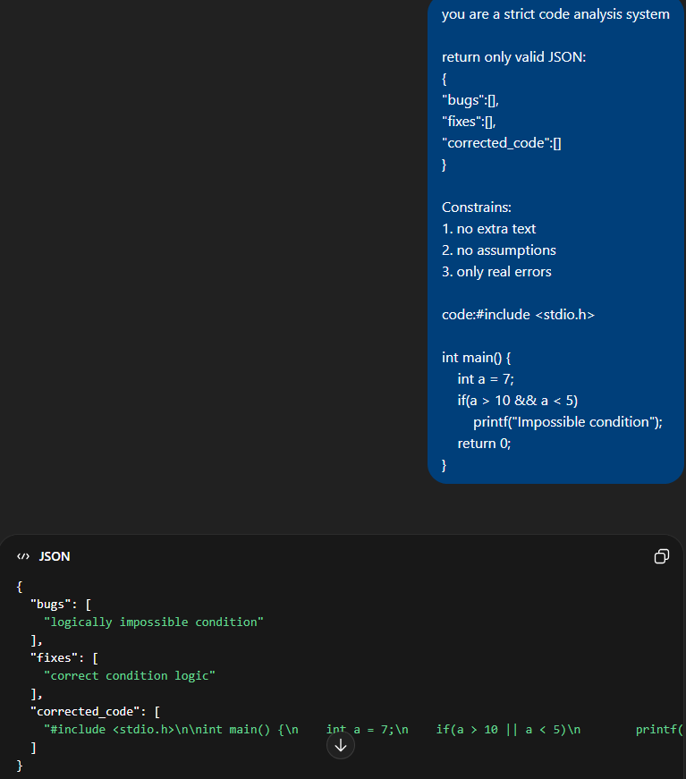

- Chain-of-Thought Prompt
Define Chain of Thought (CoT) Prompt: Chain-of-Thought prompting encourages step-by-step reasoning.
Zero-Shot CoT Prompt 1 :
Analyze step-by-step:
1. Understand code
2. Identify bugs
3. Suggest improvements

Sr. no | Output from --- ChatGPT | Output from --- Gemini | Output from --- Copilot | Analysis
Step 1 | Logic identified | Same | Same | Clear reasoning
Step 2 | Bugs found | Same | Same | Accurate
Step 3 | Fixes suggested | Same | Same | Detailed
Prompt Failures & Biases Identified: Verbose outputs
Prompt Refinement: Limit explanation length → improves clarity
Original prompt: Analyze this code
Refined prompt: You are a senior software engineer. Identify only logical and runtime errors. Do not assume missing context. Return structured output.
Before vs after output comparison: The refined prompt produced more accurate, consistent, and structured results with reduced ambiguity.
Use Case:
- Complex debugging
- Logical reasoning tasks
Zero-Shot CoT Prompt 2:
Analyze step-by-step:
1. Check variable initialization
2. Evaluate condition
3. Identify logical flaws
Code:
int x;
if(x > 0) printf("Positive");
Sr. no | Output from --- ChatGPT | Output from --- Gemini | Output from --- Copilot | Analysis
Step 1 | Detects uninitialized | Same | Same | Good reasoning
Step 2 | Evaluates condition | Same | Same | Correct
Step 3 | Suggests fix | Same | Same | Detailed
Prompt Failures & Biases Identified: Verbose output increases length unnecessarily
Original prompt: Analyze this code
Refined prompt: You are a senior software engineer. Identify only logical and runtime errors. Do not assume missing context. Return structured output.
Before vs after output comparison: The refined prompt produced more accurate, consistent, and structured results with reduced ambiguity.
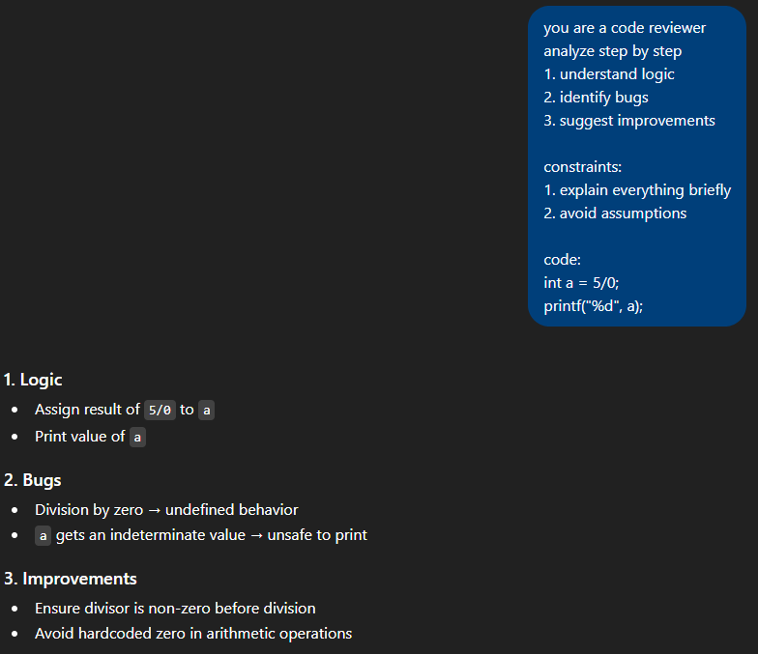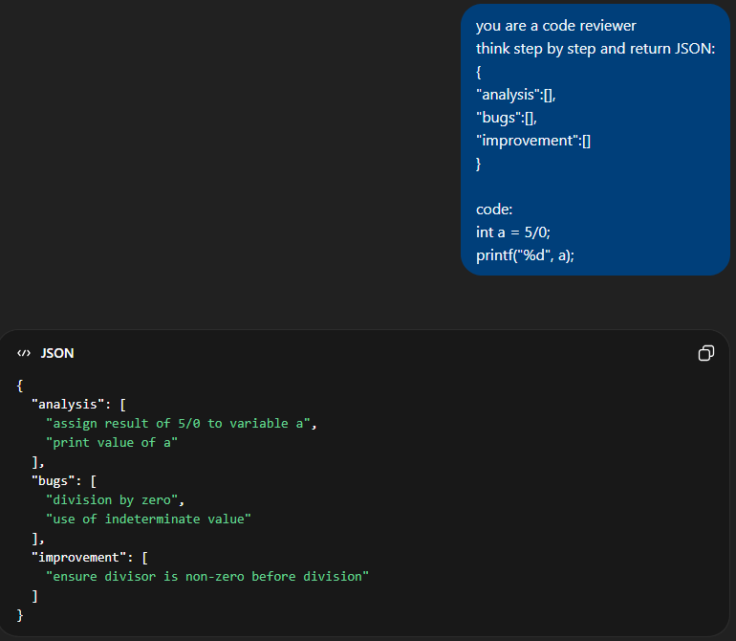
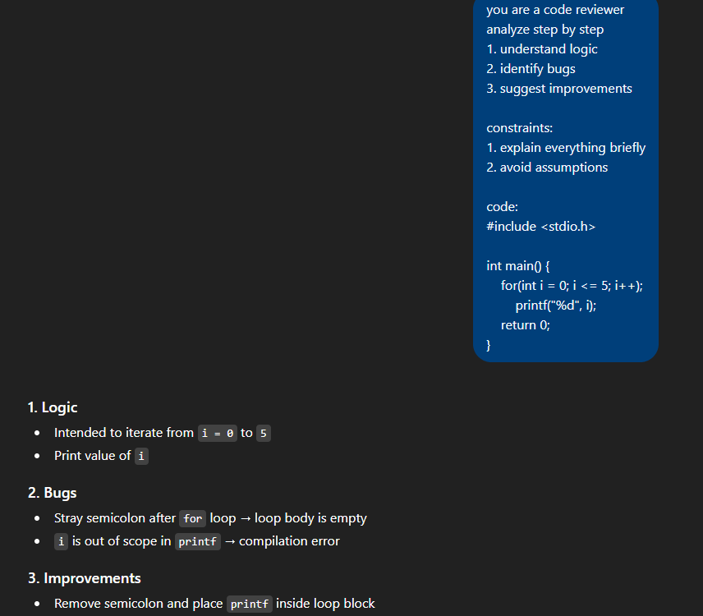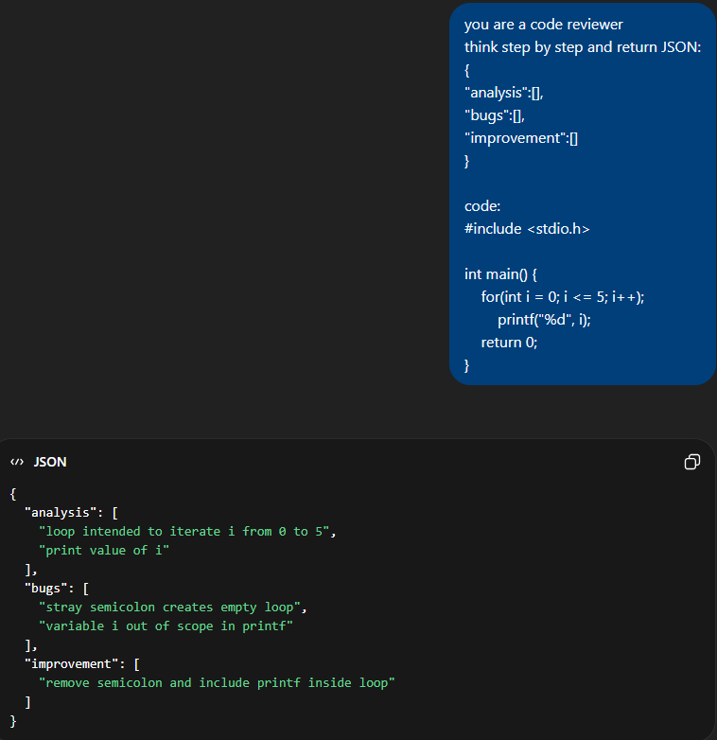
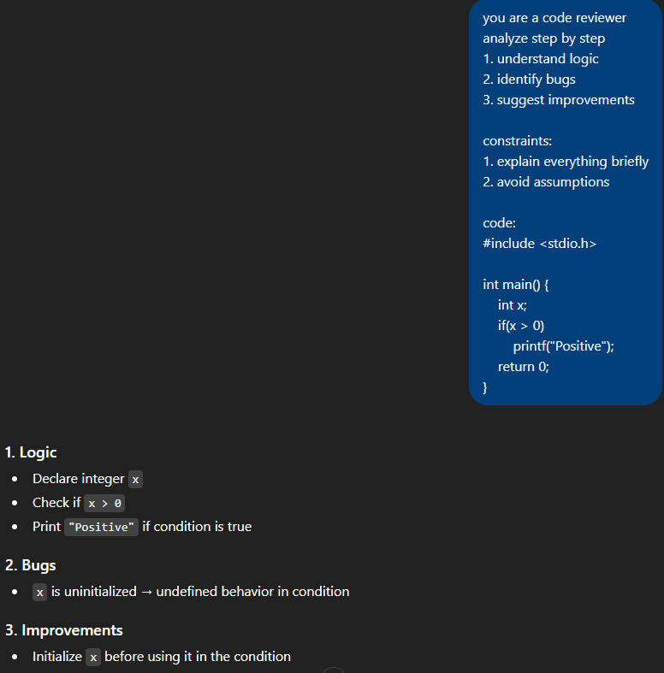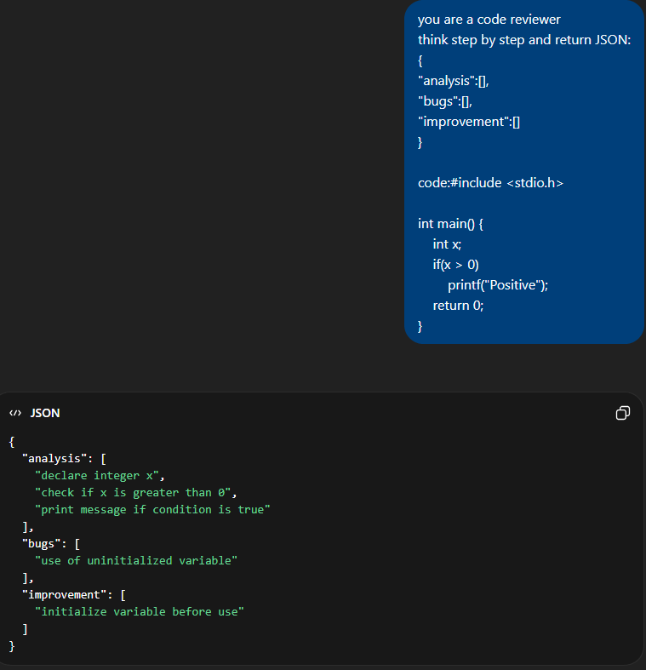
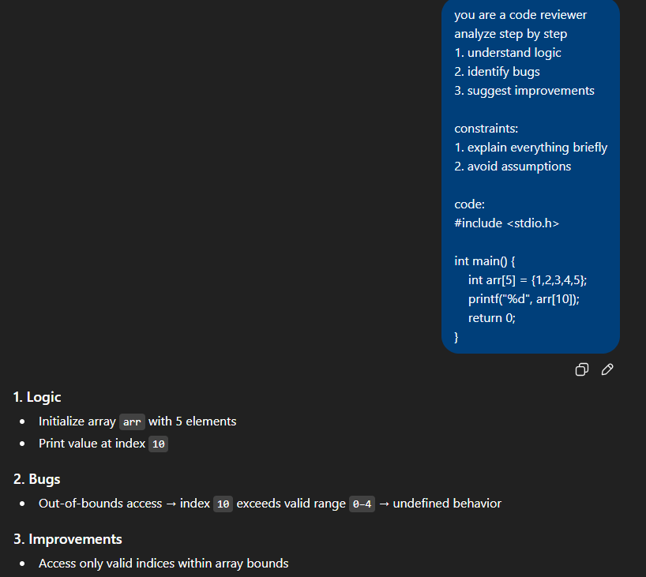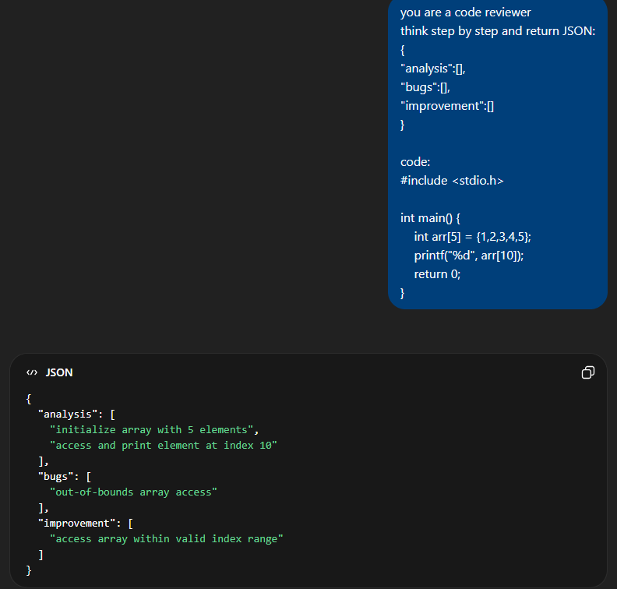
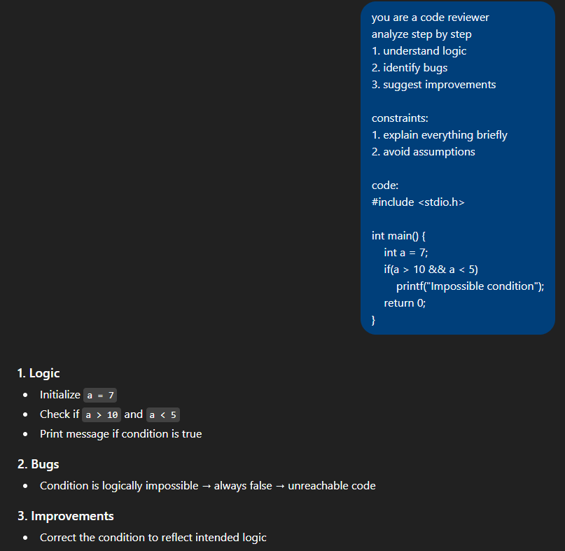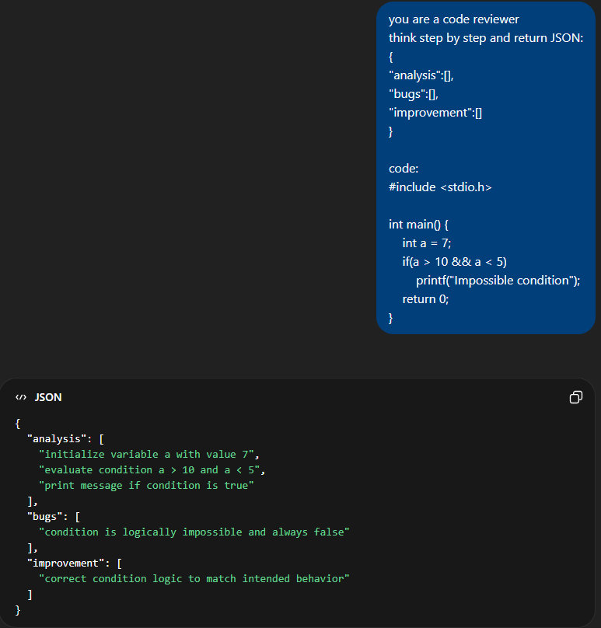

- Natural language outputs are easier to interpret but may lack consistency.
- JSON outputs provide structured, predictable, and machine-readable results, making them more suitable for automation and integration.

Prompt Type | Accuracy | Clarity | Structure
Zero-shot | Medium | Medium | Low
Few-shot | High | High | Medium
Role-based | High | High | High
CoT | Very High | Very High | Medium
JSON | High | High | Very High

Failure Summary:
- Hallucination: Incorrect bug detection
- Ambiguity: Inconsistent outputs for unclear code
- Over-generalization: Unnecessary suggestions

Discussion, takeaway
Prompt engineering significantly affects model performance. Structured prompts and constraints improve reliability and consistency. Different prompting strategies significantly influence not only accuracy but also the structure and interpretability of LLM outputs.

Conclusion
This study demonstrates that carefully designed prompts improve the accuracy, clarity, and usability of LLM outputs. Structured prompting techniques such as role-based and JSON-based prompts provide the best results. This experiment highlights that prompt engineering is critical for controlling LLM behavior in real-world applications.

References
- OpenAI Documentation
- Google Gemini Docs
- Prompt Engineering Guide (OpenAI)

